**Dev Testing - NTSWSC-1120 - Backend - Create an admin page for GUI_SUPPORT only that allows users to change the SARF SITE value on sites**

Updated getCandidateSites API of projects-service:

**Request**:

{"siteProjectsId":"2028099","status":"Proposed,Accepted,RE-Rejected,Deleted,Primary,Live"}

**Response:**

New fields sarfSite and mdgLocationId are returned in the response

[

{

"siteId": "",

"siteInfoId": 616131219,

"pplSoftLocCode": "282384",

"source": "PROJECTS",

"siteName": "TAPPAN ZEE BRIDGE - A",

"type": "MACRO",

"subType": "TRADITIONAL",

"category": null,

"status": "Primary",

"longitude": "-73.863203",

"latitude": "41.065774",

"addressLine1": "333 South Broadway",

"addressLine2": "",

"city": "Tarrytown",

"state": "NY",

"zip": "10591",

"county": "Westchester",

"rfCost": "",

"reCost": "",

"constructionCost": "",

"transportCost": "",

"atollStatus": "",

"graniteStatus": "",

"rfRanking": 2,

"docPath": "",

"docName": "",

"siteCommentsCnt": 0,

"hqreFlowId": 0,

"initialTerm": "0",

"lengthOfTerm": "0",

"originalTerm": "N/A",

"escallationPrec": "",

"escallationType": "",

"numOfRenewalTerm": null,

"specialTermsOrPayments": "",

"lastModifiedBy": null,

"lastModifiedDate": null,

"towerType": "Monopole",

"towerOwner": "Pheonix Tower - NYSTA Site",

"e911AddressLine1": "333 South Broadway",

"e911AddressLine2": "",

"e911City": "Tarrytown",

"e911State": "NY",

"e911Zip": "10591",

"e911County": "Westchester",

"fiveGMarketName": "",

"fiveGMarketCity": "",

"latitudeDegree": "41° ",

"latitudeMinute": "3' ",

"latitudeSeconds": "56.7864\" ",

"longitudeDegree": "73° ",

"longitudeMinute": "51' ",

"longitudeSeconds": "47.5308\" ",

"latitudeDMS": "41° 3' 56.7864\" N",

"longitudeDMS": "73° 51' 47.5308\" W",

"latitudeDirection": "N",

"longitudeDirection": "W",

"sarfSite": "YES",

"mdgLocationId": "5000181172",

"distance": "8276"

}

]

**updateSarfSite API:**

Added a new API updateSarfSite in site-service

Before updating the sarf_site status:

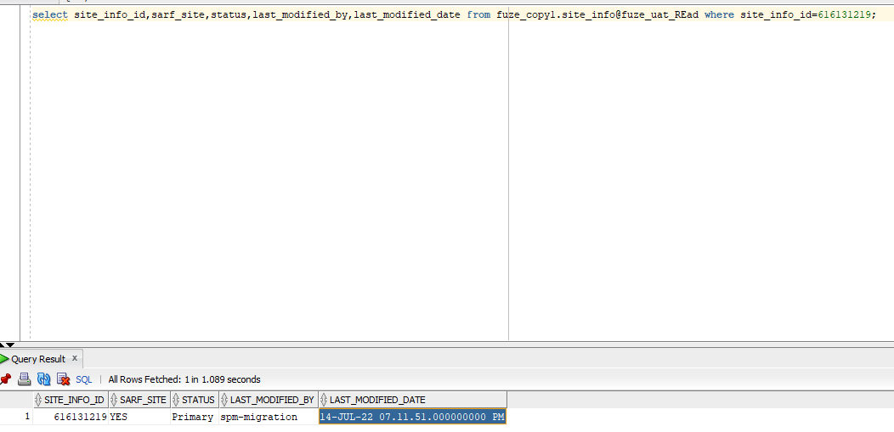

Request to update sarf site:

[

{

"siteInfoId": 616131219,

"sarfSite": "NO",

"lastModifiedBy":"kja2hhd"

}

]

After updating the sarf site:

select site_info_id,sarf_site,status,last_modified_by,last_modified_date from fuze_copy1.site_info where site_info_id=616131219;

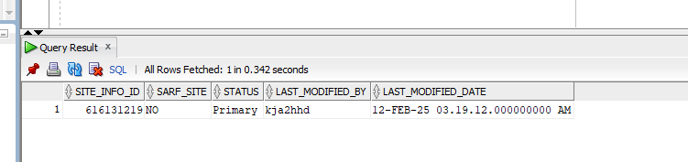

select site_info_id,sarf_site,site_status,last_modified_by,last_modified_date from fuze_copy1.sites_tracker_data where site_info_id=616131219;

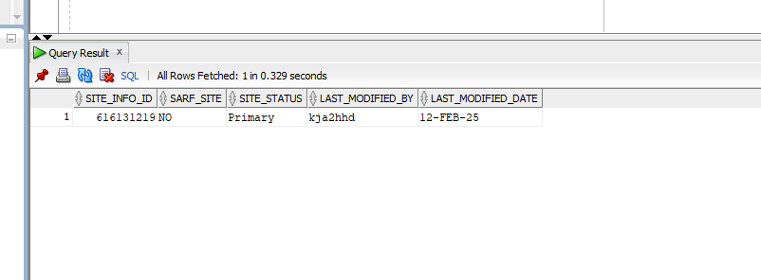

**Request to update the status:**

[

{

"siteInfoId": 616131219,

"sarfSite": "NO",

"lastModifiedBy":"kja2hhd",

"status":"Live"

}

]

After updating the status: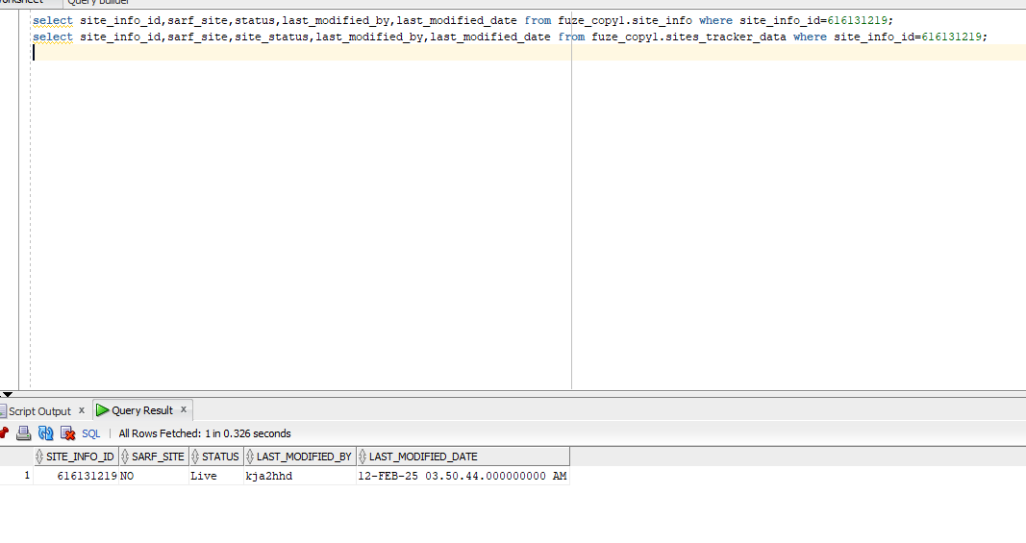

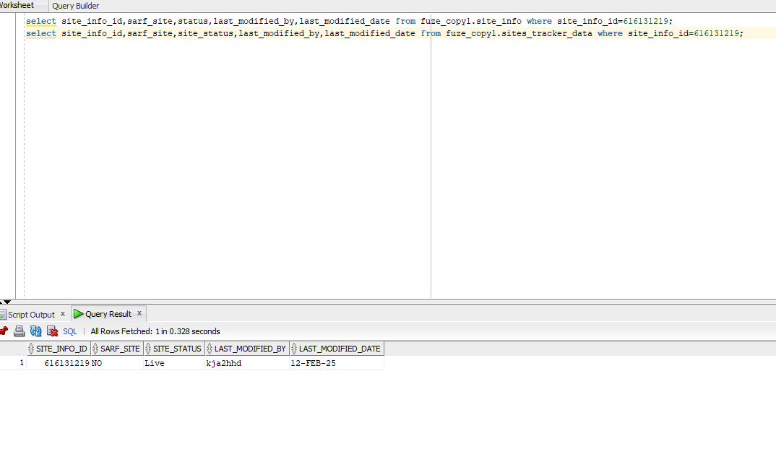

**Request to update both sarf site and status:**

[

{

"siteInfoId": 616131219,

"sarfSite": "Yes",

"lastModifiedBy":"kja2hhd",

"status":"Primary"

}

]

After updating sarf site and status:

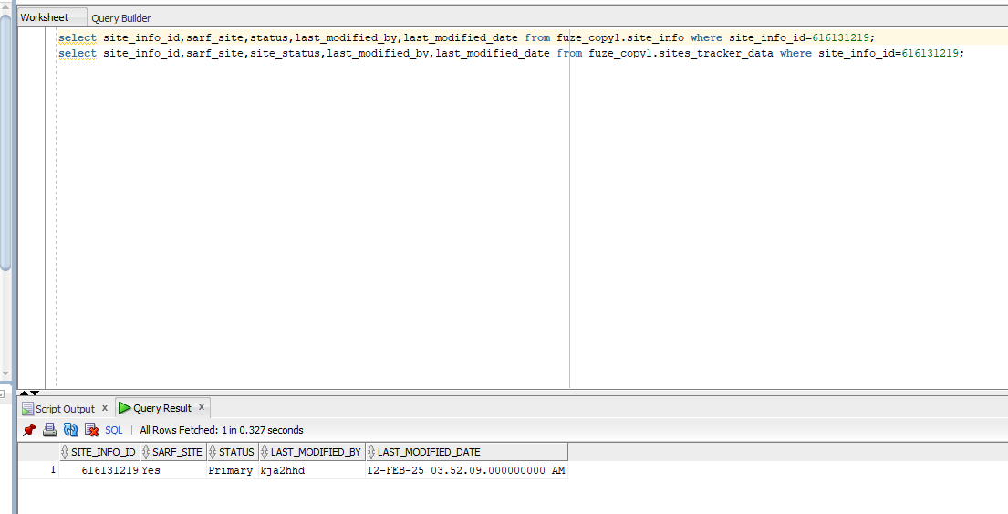

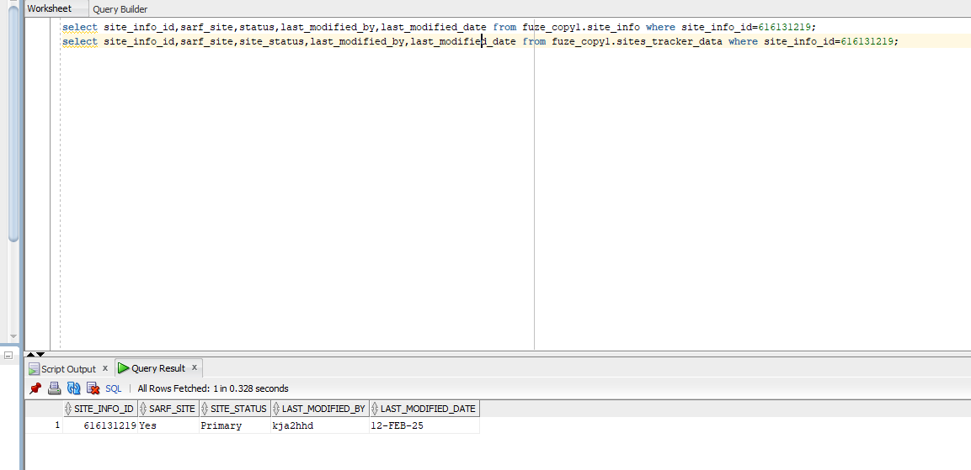

Before updating 2 sites:

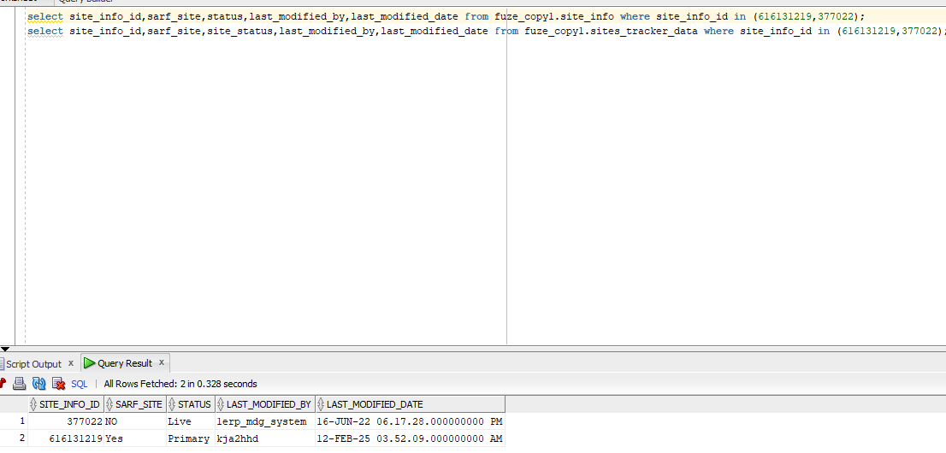

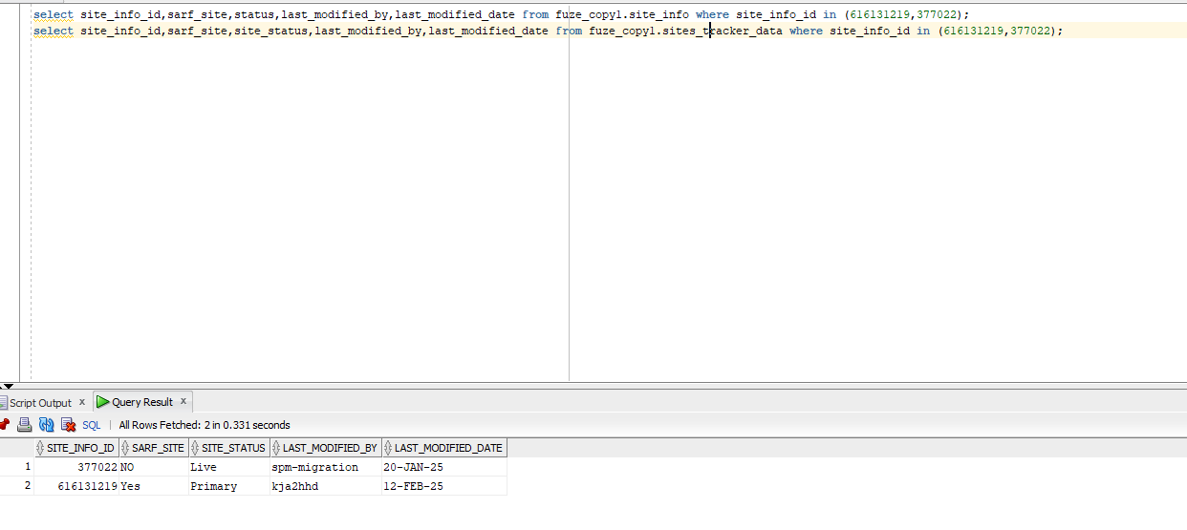

Request:

[

{

"siteInfoId": 616131219,

"sarfSite": "Yes",

"lastModifiedBy":"kja2hhd",

"status":"Live"

},

{

"siteInfoId": 377022,

"sarfSite": "Yes",

"lastModifiedBy":"kja2hhd",

"status":"Primary"

}

]

